Course: SAT ACT Prep
Subject: Mathematical Reasoning
Topic: Arithmetic
Subtopic: Operations with Radicals
Document: Quick Drill A Resource
Lesson Number: 4
Reference Number: 1004-7

https://youtube.com/c/MrMattTheTutor

- What is the value of the expression $\left(\frac{X^{2}+2}{Y^{2}-3}\right)$ when $X=2\sqrt{2}$ and $Y=3\sqrt{2}$ ?
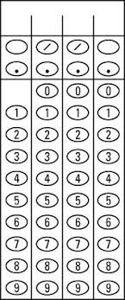
- What is the value of the expression ${\left(\frac{2X+Y}{2Y-X}\right)}^{2}$ when $X=3\sqrt{2}$ and $Y=2\sqrt{2}$ ?

- If $\sqrt[3]{27}+\sqrt[2]{Y}=\sqrt[3]{125}$, what is the value of Y?

- If $\sqrt[3]{64}+\sqrt[2]{Y}=\sqrt[3]{216}$, what is the value of Y?

- If $\frac{\sqrt[3]{M}}{3}$ is a positive integer, what is the smallest possible positive integer value of M?

- If $\frac{\sqrt[4]{N}}{4}$ is a positive even integer, what is the smallest possible positive integer value of N?

