Course: SAT ACT Prep
Subject: Mathematical Reasoning
Topic: Arithmetic
Subtopic: LCM and GCF
Document: Quick Drill B Resource
Lesson Number: 3
Reference Number: 1002-8

https://youtube.com/c/MrMattTheTutor

- What number less than 20 has a remainder of 2 when divided by 2, 3, and 6?
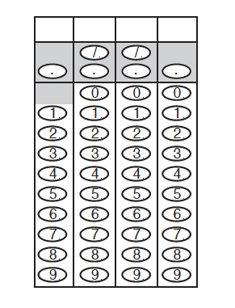

- What number less than 200 has a remainder of 5 when divided by 6, 8, and 18?

- What number less than 200 has a remainder of 11 when divided by 16, 18, and 24?

- At Rosalinda’s restaurant there is a fruit salad made of pineapples, oranges, and apples. Each pineapple is cut into 32 chunks, each orange is separated into 8 slices, and each apple is cut into 12 chunks. If a food delivery brings 26 pineapples, 78 oranges, and 65 apples, what is the greatest number of identical fruit salads can be made while using every piece of fruit from the food delivery?
- At Johnathan’s restaurant there is a fruit salad made of kiwi fruits, dragon fruit, and bananas. Each kiwi fruit is cut into 8 chunks, each dragon fruit is cut into 18 slices, and one banana is cut into 12 slices. If a food delivery brings 75 kiwi fruits, 30 dragon fruits, and 45 bananas, what fraction of each identical fruit salad consists of bananas if every piece of fruit from the food delivery is used?
- At Fredericka’s restaurant there is a fruit salad made of mangos, cherries, and apricots. Each mango is cut into 18 chunks, each cherry is quartered, and each apricot is cut into 8 chunks. If a food delivery brings 22 mangos, 132 cherries, and 44 apricots, what fraction of each identical fruit salad consists of mangos if every piece of fruit from the food delivery is used?

